INTRODUCTION
Campus Network for Bells University
Designed using Hierarchal model
Implemented in Cisco Packet Tracer
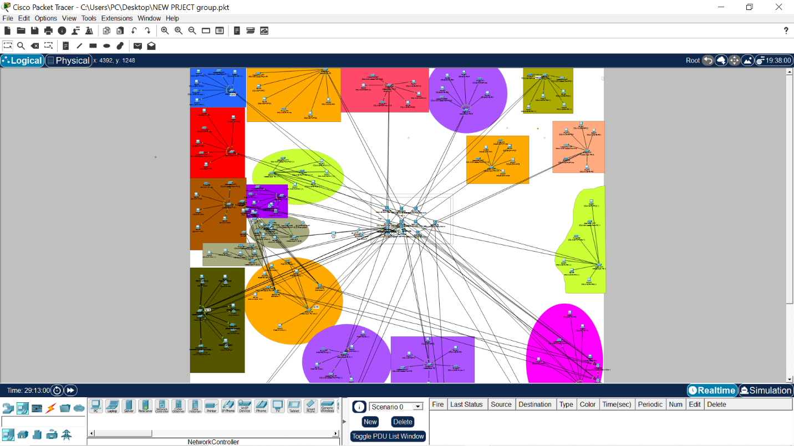

2. NETWORK DESIGN

2.1 Design Approach
The bells University campus Network was designed using a hierarchical network model, which divides the network into three logical layers: Core, Distribution, and Access. This approach was chosen because it improves scalability, simplifies troubleshooting, and ensures high availability access the campus.
The design reflects a real-life University Campus, where multiple academic and administrative buildings are interconnected through a central backbone.

2.2 Hierarchical Network Model

2.2.1 Core Layer
The core layer forms the backbone of the entire campus network. Two Cisco 3560 multilayer switches were deployed at the core to provide redundancy and high-speed routing between buildings
The core layer is responsible for:
- Fast and reliable routing between buildings
- High availability (no single point of failure)
- Interconnecting all distribution switches from different buildings
- No end devices to User VLANs are connected to the core layer

2.2.2 Distribution Layer
Each building in the campus has two distribution switches (Cisco 3560). These switches serve as the control point between the core the access layers.
The distribution layer performs the following functions:
- Inter-VLAN routing using switch virtual interfaces
- Acting as the default gateway for end devices
- Implementing redundancy using HSPR
- Aggregating traffic from multiple access switches
- Having two distribution switches per building ensures network availability if one switch fails.

2.2.3 Access Layer
The access layer is deployed on a per-floor basis within each building. Cisco 2960 switches are used at this layer to connect end-user devices such as PCs, printers, and wireless access points.
The access layer is responsible for:
- Connecting end devices to the network
- Assigning devices to VLANs
- Forwarding traffic to the distribution layer
Each floor contains its own access switch, making the network easier to manage and expand.

2.3 Campus Buildings and Floor Structure
The campus network design includes the following buildings based on the real Bells University layout:
- College of Engineering (4 floors)
- College of Natural & Applied Sciences (4 floors)
- College of Management Sciences (4 floors)
- Postgraduate School & Research Labs (4 floors)
- Library & ICT Directorate (4 floors)
- Hostels (6 floors)
- Admin Block & Senate Building (2 floors)
- Health Centre & Cafeteria (2 floors)
- Gatehouse & Security (2 floors)
Each floor is treated as a logical segment of the network and connected through an access switch to the building’s distribution layer.

2.4 Redundancy and Reliability
To ensure continuous network availability:
- Dual core switches were used at the campus backbone
- Dual distribution switches were deployed per building
- Multiple physical links were used between access and distribution layers
This design minimizes downtime and allows traffic to continue flowing even in the event of device or link failure.

2.5 Simulation Tool
The entire network was designed and implemented using Cisco Packet Tracer, which allows for realistic simulation of Cisco devices, configurations, and network behavior.

3. NETWORK IMPLEMENTATION
I designed and implemented the Physical Campus network topology for Bells University of Technology based on the project specification. The campus was modeled using real building structures and floor layouts. Each building was represented with its actual number of floors and organized using access, distribution, and core layers.
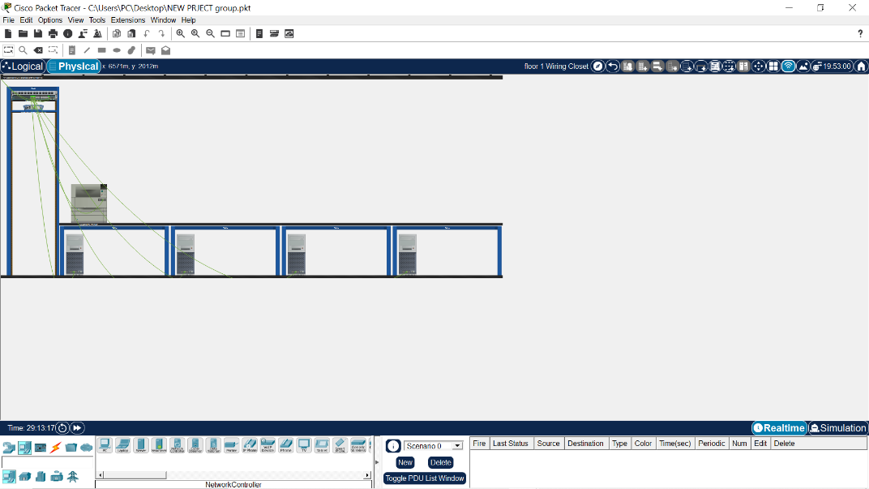
I deployed two core switches to serve as the campus backbone. Each building was assigned two distribution switches for redundancy and scalability. All floors within a building were connected using access switches. The distribution switches of every building were connected directly to both core switches to ensure high availability.
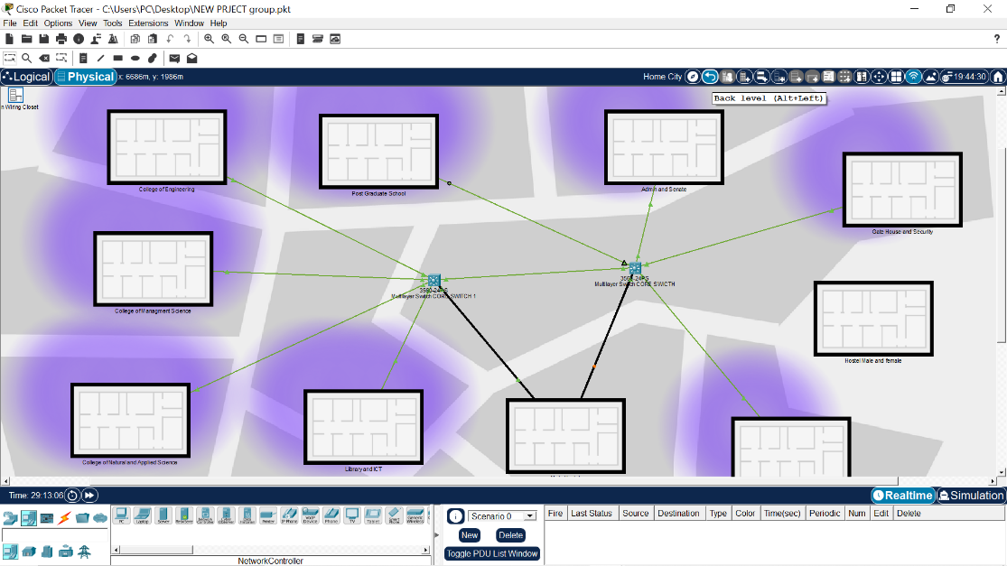
After completing the physical topology, I designed a campus- wide VLAN numbering plan to logically separate departments, staff, students, management, servers, and wireless users.
I then began the logical configuration phase by creating VLANs on the distribution switches of the College of Engineering building as a reference model for other buildings.
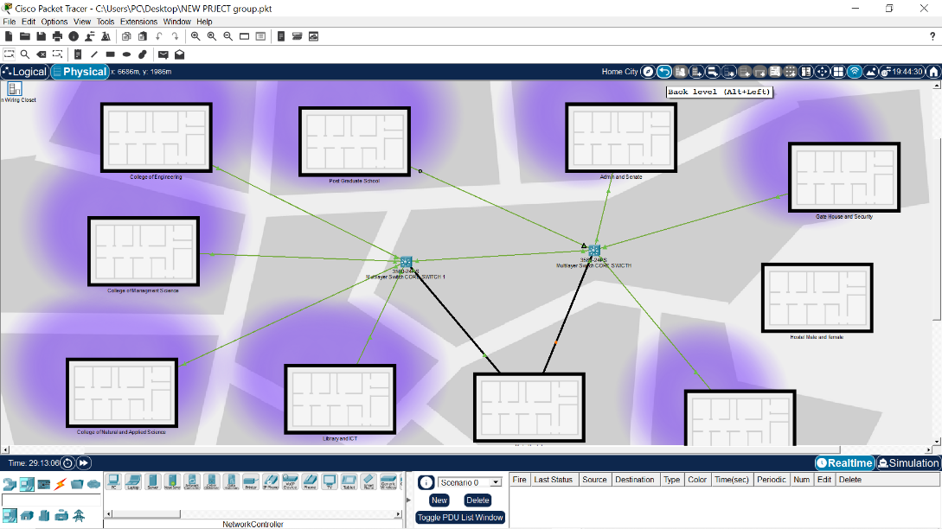
Building and floors were modeled using packet tracer city view and closets.
Access switches (2960) were placed per floor and connected to distribution switches.
Distribution Switches (3560) were connected redundantly to both core switches.
VLANs were created using the cisco IOS CLI on the distribution switches.
Configurations were saved to ensure persistence after reboot.

3.1 CURRENT STATUS
Physical topology: Completed
Core and distribution connectivity: completed
VLAN planning: Completed
VLAN configuration: in progress
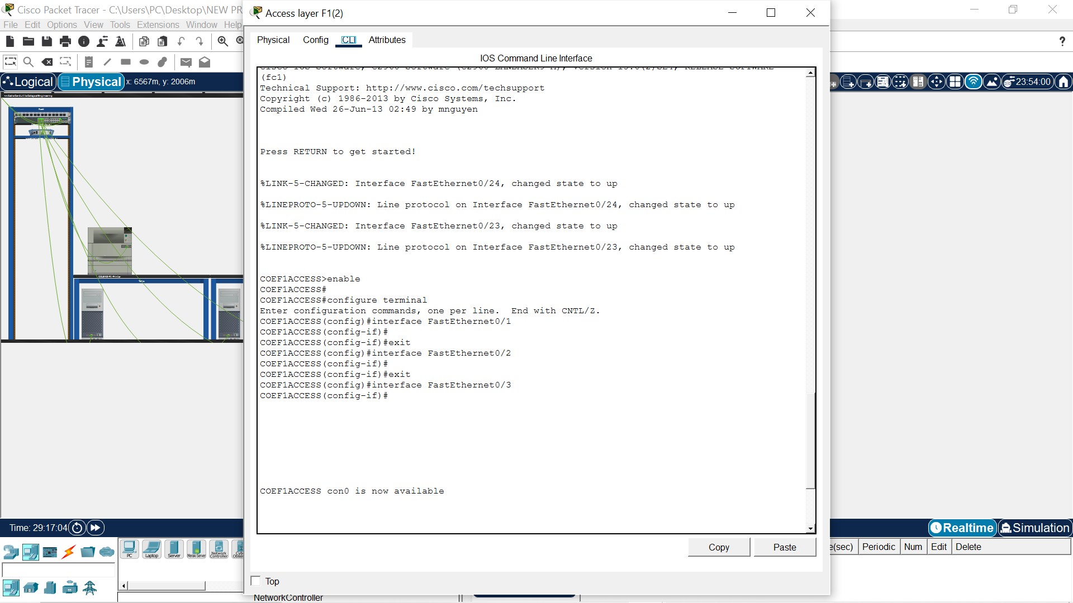

4. CONFIGURATION OVERVIEW

4.1 VLANs Configuration
Virtual local area network was implemented to logically segment the campus network and reduce unnecessary broadcast traffic. VLANs allow devices to be grouped based on function or department rather than physical location.
In this project, VLANs were created on both access and distribution switches to ensure consistency across the network. End devices such as PCs and printers were assigned to VLANs through access ports on Cisco 2960 switches. This approach Improves network organization and prepares the network for future expansion.

4.2 Inter-VLAN routing
Inter-VLAN routing has implemented at the Distribution layer using Cisco 3560 multilayer switches. Switch Virtual interfaces (SVI) were created for VLAN to act as default gateways for end devices.

4.3 HSRP
Configurations were implemented gradually and tested per building.

5. CONCLUSION AND FUTURE WORK

5.1 Conclusion
This project successfully demonstrates the design and initial implementation of a campus network for Bells University of Technology using Cisco Packet Tracer. A hierarchical network architecture was adopted to ensure scalability, reliability, and ease of management across multiple academic and administrative buildings.
The network design incorporates core, distribution, and access layers, with redundancy built into critical components such as the core and distribution switches. VLANs were implemented to logically separate network traffic, and inter-VLAN routing was configured at the distribution layer to allow communication between different segments of the network. High availability was achieved using HSRP, ensuring uninterrupted access to network services in the event of device failure.
Through this project, practical knowledge of campus network design, device configuration, and troubleshooting was gained, reinforcing key CCNA concepts in a real-world scenario.

5.2 Limitations
Due to the scope and time constraints of the project, some advanced features were implemented in a simulated environment only. While Cisco Packet Tracer provides a realistic platform for learning, it does not fully replicate all real-world behaviors of enterprise networks.
Additionally, some configurations such as full-scale wireless authentication and advanced security policies were simplified during the initial implementation phase.

5.3 Future Work
The network design allows for future enhancements and expansion. Planned future improvements include:
- Implementation of a centralized DHCP server with DHCP relay across VLANs
- Deployment of OSPF for dynamic routing between buildings
- Full implementation of IPv6 dual-stack networking
- Integration of wireless networks with secure authentication mechanisms
- Configuration of network security features such as ACLs and firewall policies
- Implementation of network monitoring tools including Syslog, SNMP, and NetFlow
These improvements will further enhance the security, scalability, and performance of the campus network.

